**Over 10% of adults in Sandwell have diabetes. Higher than West Midlands 8.2% and National average 7.3% - and rising!**

**Type 2 diabetes prevention week 2024**

(Monday 20th May to Sunday 26th May)

 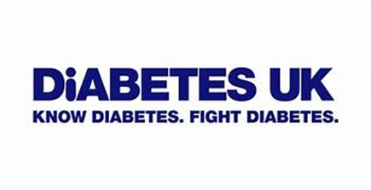 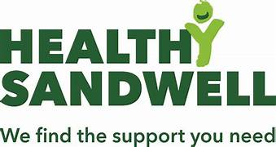

**Sandwell Aquatics Centre**

**worked together to raise awareness of diabetes risks and provide information.**

**We spoke to 50+** people from Sandwell, over 40 years old, male and female of British, European, African, African Caribbean and South Asian ethnicities.

**We promoted Diabetes UK information and helpline:**

**Diabetes UK Helpline** - Phone: 0345 123 2399

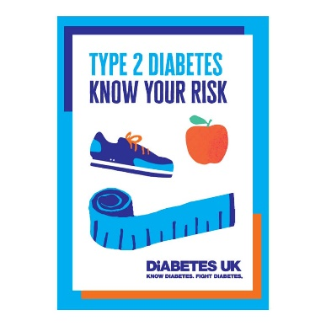

**Free Booklet:**

<https://shop.diabetes.org.uk/products/type-2-diabetes-know-your-risk>

**On-line tool:**

<https://riskscore.diabetes.org.uk/start>

***“It is great to have people locally providing this information.”***

**We heard:**

* People want information about diabetes signs, symptoms and risk factors
* People want more information about healthy eating and being physically active
* Challenges with managing pre-diabetes and diabetes
* Concerns about family members with diabetes and associated risks

**To find out more and help raise diabetes awareness:**

[10th - 16th June Diabetes week free resources | Diabetes UK](https://www.diabetes.org.uk/forms/diabetes-week-resources)

[Healthwatch Sandwell: Diabetes in Sandwell - Report with recommendations (March 2024)](https://www.healthwatchsandwell.co.uk/report/2024-03-26/diabetes-sandwell-march-2024)