Older People – aging and diabetes - are services meeting needs?
Our priority project for 2023/24 is looking at peoples’ experiences of living with and managing diabetes, and of health, care and support services.
We have teamed up with Diabetes UK and are working in partnership local community organisations to reach and hear from Sandwell residents with diabetes, or pre-diabetes.
Diabetes UK has highlighted that more research is needed on the impacts of becoming elderly and managing diabetes. As people age some may become frail and have other health conditions including having an increased risk of vascular dementia with diabetes.
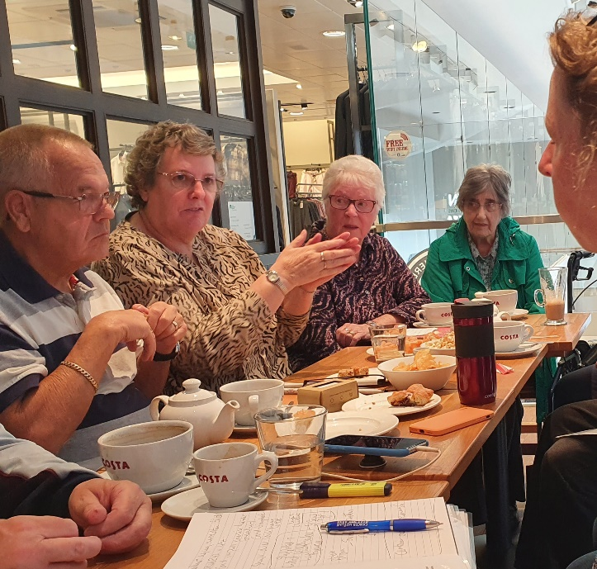
We held conversations with older people and carers in the community and at St Albans day centre. We heard about experiences of aging, managing diabetes and for some people the challenges that come with becoming elderly and frail.
What we have heard will be included in our Diabetes report due to be published early in 2024. The report will include suggestions for helping manage diabetes as people age and make recommendations for improvements to health, care and support services.
Insights gathered from the conversations on impact on diabetes management as people age include:
- Reduced mobility and weight bearing impact on being able to be physically active
- Independence can be affected e.g. ability to shop and prepare food, transport needs
- Forgetfulness affecting taking medications, arranging and attending appointments
- Carers may not have much understanding of diabetes and managing the impacts.
“I need support with knowing when to get my diabetes checked. I can be forgetful so a reminder would be good.”
“My husband has mobility issues - taxi’s to all his health appointments are expensive!”
Mr A had a stroke a few years ago and was prescribed slow release tablets for his diabetes “It’s the best thing that happened, my diabetes doesn’t go up and down so much now.”
Mrs B told Healthwatch that her son supports her with her diet to reduce sugar and salt intake. This has made a big difference this year and helped her lose weight. Her son has actively sought information on diabetes to support her.

